# NE 445L/461 Nano-Instrumentation Lab Report

## 

University of Waterloo  
4A Nanotechnology Engineering  
Group 7

#### Rajesh Swaminathan Student ID: 20194189 Lab Partner: Peter Lee (20201956)

**Dates Lab Performed On:** Oct 27, Nov 3, and Nov 10 2009  
**Lab Report Submitted** on Nov 24 2009  
**Lab Instructor**: Rob Donkers

### Introduction and Objective

The primary objective of the NE 461 laboratory is to understand the working and operation of a quartz crystal microbalance (QCM) for measuring sub-micron mass changes. This lab is split into 3 sessions. The first session attempts to detail the theoretical underpinnings of a simple oscillator circuit which the foundation of any QCM setup. The second session helps us understand the sensitivity of the QCM to minute changes in solution viscosity, density and temperature in which it is immersed. It also gives us the temperature range within which the QCM operates. The third lab session involves the deposition of a self-assembled monolayer (SAM) of first mercaptoundecanoic acid and then lead acetate on the gold surface of the QCM. This procedure helps us monitor the growth of the monolayer by detecting small changes in mass through a change in QCM frequency. The thickness is later verified using ellipsometry.

**Experimental Procedure**

### The NE 461 laboratory was performed according to the procedures outlined in the NE 454L/NE 461 Nano Instrumentation Laboratory Manual of the Nanotechnology Engineering Program 4A Labs, 2009 found on UW-ACE. Versions 1.5, 1.7 and 1.5 of the lab manuals were used for the first, second and third lab sessions respectively.

The label of the QCM assigned to our lab group in Lab 2 was QCM 1-09A. A different QCM was assigned to us for Lab 3, namely QCM 5-09A. The lead acetate solution assigned to our group was 1 mL of a ¼th dilution of the 50 mM stock lead acetate solution. The concentration of this dilution was therefore 50/4 = 12.5 mM.

**Results and Discussion**

**Lab 1 Discussion: Oscillator Simulation Calculations**

***Exercise 1.7***

A transient analysis was performed with R1=1 kΩ and 10 kΩ. The results are shown in and in Appendix A. From these plots we see that when R1 is 10 kΩ, there is significantly more dampening and the resonance dies out faster as compared to when R1 is only 1 kΩ. This makes sense since the more overall resistance there is in the circuit, the harder it will be to set up a stable resonance, and the easier it will be for the signal to dampen and die out.

***Exercise 1.8***

Both capacitors used in the exercise were each 200 nF. Thus the effective capacitance in series is .

In varying the resistance for R1 from 1 kΩ to 10 kΩ, we observed more damping.

***Exercise 1.9***

The value of L used in this exercise was 100 mH while the value of C was 50 nF.

Thus calculated frequency 

From the Fourier Transform (FFT) plot in in Appendix A, we can see that the first peak is at roughly 2.8 kHz resulting in a percent difference of from the calculated value.

This percent difference between the two values can be rationalized by taking into account the fact that other circuit components such as diodes were added in this exercise. The equation used to calculate the resonant frequency, namely, assumes a basic RLC band-pass circuit while the computer simulator software PSPICE uses more detailed and complex formulas to take into account the addition of the diodes.

***Exercise 1.10***

The capacitor used in this exercise was 50 nF while the inductor used was 100 H giving an expected resonant frequency of . As can be seen in in Appendix A, the measured frequency is 71.6 kHz. This is a percent difference of . This difference is negligible since it is within the error levels of the instrument.

***Discussion of Lab 1 Results***

Our lab group observed that the transistor oscillator we built in Exercise 1.10 was able to achieve a good stability of ±1 Hz recorded over a minute. Thus, if the frequency changes are on the order of 1-2 Hz in subsequent labs, this system cannot be used since it would be impossible to differentiate if the drop was due to a random drift or a mass/temperature change. As we will see in Lab 3, the frequency drop going from stock lead acetate solution to a ¼th dilution is on the order of 1.5 Hz.

It is also quite important to note the limitations in using a simple breadboard setup with several circuit components connected so closely to each other without proper insulation in between. There are small capacitances between the various unshielded elements and wires, as well as appreciable amounts of magnetic fields surrounding the 100 H inductor which introduce a loss in frequency stability. While these factors may be insignificant in other circuits, it is not the case in this oscillator circuit since we are attempting to achieve stability on the order of 1 Hz which is quite small.

**Lab 2 Discussion: Validating the QCM**

As we vary the solvent the QCM is immersed in from ambient air to the various solvents, we noticed a shift in the resonant frequency as anticipated. These shifts are primarily because the different solvents all have different densities and different viscosities. The values obtained were quite close to that calculated in the pre-lab.

Table 1: Differences in the Actual and Calculated Frequency Shifts

|  |  |  |  |
| --- | --- | --- | --- |
| Solvent | Actual Frequency Shift (Hz) | Calculated Frequency Shift (Hz) | Percent Difference (%) |
| Water | -687 | -711.52 | 3.4% |
| Ethanol | -731 | -693.37 | 5.43% |
| Ethylene Glycol | -2936 | -3016.75 | 2.67% |

As can be seen in , the maximum percent difference for the three solvents studied is within an acceptable value of 6%. These small percent differences for the 3 solvents could be explained by considering that the stock solutions given to us weren’t a 100% pure. Any impurities in the solution would have changed its density and viscosity values yielding different frequency shifts. Further, the hygroscopic properties, i.e. the water-absorbing properties of ethanol and ethylene glycol could serve to reduce the frequency shifts observed.

The frequency shifts of the QCM as a function of temperature change along with the calculated values from the pre-lab were plotted together in

Figure 11 of Appendix B. In this plot, we see that the theory and experiment match up together until about 25 degrees, but as the temperature is increased to higher values, the two curves diverge from one another. The experimental values for the frequency are lower than what was calculated in the pre-lab.

This discrepancy between theory and experiment can be attributed to the simplicity of the model used to calculate the theoretical values for frequency shift. The model we used takes into account only the density and viscosity of the solvent. However, in reality, there are way more parameter that affect the QCM’s operation. In particular, there is an optimal temperature range where the QCM can be considered effective and can be explained by theory. Outside this range, the QCM’s sensitivity to external uncontrollable parameters, device defects, become more significant. Outside this range, the nature, quality, adherence properties and cut of the quartz become significant. From

Figure 11 of Appendix B, we see that the frequency shifts of the QCM we used can be predicted by theory within the range of 10 to 25 degrees.

The key lesson taken from Lab 2 was the usefulness of validating the QCM before it was put to use in Lab 3. This important step establishes a level of certainty and reproducibility of the QCM device. If in a future lab the QCM failed to yield sensible results, we can always take a step backward and re-validate it once again. This validation step also helps us determine the effective temperature range within which the QCM can be considered effective for sub micro-gram mass measurements.

**Lab 3 Discussion: Using the QCM to Detect Mass**

The plot and QCM readout for how the frequency changes with time as the mercaptoundecanoic acid (MUA) is added to the solution can be found in in Appendix C. There was some drifting of the frequencies that was observed while we were recording our data. Thus, in order to remove the effects of this drift, we assumed a constant level of drift throughout our experiment and subtracted out this drift amount from our obtained data to obtained “normalized” data points that don’t contain any drifting. We can later compare the results of the following analysis and see if the drifting made a significant change to our results.

The following table, (a reproduction of ), summarizes the results of the analysis done on the data obtained in the lab. The analysis and sample calculations are shown in Appendix C. The formulas and constants used were obtained either from the prelab or from the lab manual.

Table 2: Summary of Parameters Obtained from the Addition of Mercaptoundecanoic Acid

|  |  |  |  |
| --- | --- | --- | --- |
|  | Original Data | Normalized Data | Units |
| Δf | -3.01 | -6.09 | Hz |
| Δm | 6.83x10-8 | 1.38x10-7 | g |
| Packing factor | 2.35x10-10 | 4.76x10-10 | mol/cm2 |
| Average Footprint Area | 7.06x10-15 | 3.49x10-15 | cm2/molecule |
| Number of Gold Atoms | 5.65x1014 | 1.14x1015 | atoms |

In the pre-lab for lab #3, we calculated the footprint of each molecule to be 1.66x10-15 cm2. The values obtained from literature for the footprint is 2.40x10-15 cm2 [1] which is higher than the calculated value from the pre-lab, but lower than what was obtained from the normalized data in above. What could have yielded a higher average footprint area? One reason could be because we obtained a lower packing factor than what was anticipated. And a low packing factor could have been obtained due to a Δm recording that was less than anticipated. Possible reasons for this are 1) incomplete saturation of all the QCM sites to yield only a partial monolayer, 2) incomplete removal of organics from the QCM sites using piranha, or 3) insufficient or reduced gold atoms on the surface to enable activation of all QCM sites.

Next, we performed an ellipsometry analysis to determine our SAM’s thickness. We obtained a thickness of 45.428 ± 3.221 Å. The theoretical height we expected was around 14.3 Å, which is quite lower than what we got. Either the thickness measurement obtained from ellipsometry is incorrect due to incorrect procedure or incorrect guidance by the Ellipsometry TA, or the QCM wasn’t entirely cleaned off with ethanol to get rid of previous mercaptoundecanoic acid (MUA). We would need to obtain a more densely packed layer of MUA atoms on the surface to obtain a smaller thickness for the same number of atoms. Clearly, the packing was not very tight, perhaps because of the orientation at which each acid molecule is surrounded by other acid molecules, which results in a thicker monolayer.

Next, we added lead acetate, both stock and diluted version, to our solution to examine its effect. We determined the concentration of the lead ions on the monolayer to be 4.95x10-10 mol/cm2 for the 50 mM lead acetate stock solution, and 1.26x10-10 mol/cm2 for the one-quarter dilution. Since the lead ions completely saturate the monolayer surface because an excess of lead acetate was added, we expect the concentration of lead ions to be the same as the density of the ligands on the surface assuming each lead ion binds to one mercaptoundecanoic acid molecule. In our experiment, we observed that around 4% of the surface atoms were not bound to any lead ions, which is not unreasonable.

As can be seen in , noise levels before the addition of mercaptoundecanoic acid (MUA) were around 1.33 Hz. Noise levels *after* the addition of MUA were 0.95 Hz. The average of the two noise levels is ½(1.33+0.95) = 1.14 Hz. Since the signal before adding the MUA was 6.09 Hz, we obtain a signal-to-noise ratio of 6.09/1.14 = 5.34. If the signal-to-noise ratio was as low as 1, we would conclude that the signal isn’t really a signal and reject it as being insensible. In other words, to obtain a signal-to-noise ratio of 1, our signal would have to be equal to the noise level, i.e. 1.33 Hz which forms the instrument *limit* for frequency measurements. Clearly, the higher the noise levels, the tighter the instrument’s limit. Any measurement made below the instrument’s limit cannot be considered sensible and must be discarded.

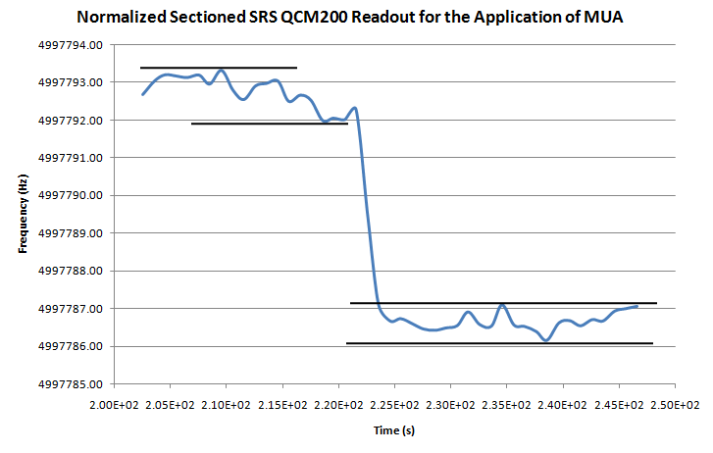

Figure 1 Analysis of Noise Levels in Data and Signal-To-Noise Ratio

We also realize that the ion binding chemistry is reversible and the strength of the bond is dependent on the pH of the solution. This allows us to simply add H+ ions (such as acetic acid) to increase the acidity of the solution thereby lowering its pH. The excess H+ ions would compete with the lead ions by making the mercaptoundecanoic acid sites uncharged. The result is that the lead ions would unbind from the mercaptoundecanoic acid molecules thereby making the ion sensing procedure in this lab automated. The acid can be added to the solution by means of a simple pipe.

**Conclusions**

From the preceding discussion, we see that the match between theory and experiment is quite satisfactory. Considerations of noise in the data are quite important since if the noise levels are comparable to the signal achieved, it leaves a large doubt about the accuracy of the result obtained. For example, significant noise levels in Lab 3 upon addition of 50 mM lead acetate leave some doubt on the results obtained in that portion of the lab. Also, in Lab 3, we were unable to obtain truly accurate data for monolayer thickness from the ellipsometer. This makes it hard to prove the correctness of the monolayer thickness obtained from monolayer mass and surface area calculations.

In summary, the QCM is an excellent device that allows us to make highly accurate sub microgram mass measurements. It can also be used for highly practical ion sensing applications. But in doing so, it is imperative to keep in mind the QCM’s limitations, its high sensitivity to temperature and solvent parameters such as density and viscosity, and its response to noise levels which can serve to reduce its potential 1 Hz stability quite appreciably.

# Appendix A

## Exercise 1.7

*Source and Load - Ex1.7

V 1 0 1

R 1 2 1k

L 2 3 100m

C 3 0 0.01n ic=2V

.TRAN .5us 1ms UIC

.PROBE

.END

JOB CONCLUDED

TOTAL JOB TIME .36

*Source and Load - Ex1.7b

V 1 0 1

R 1 2 10k

L 2 3 100m

C 3 0 0.01n IC=2V

.TRAN .5us 1ms UIC

.PROBE

.END

JOB CONCLUDED

TOTAL JOB TIME .09



Figure 2 Transient Analysis for R1=1 kΩ

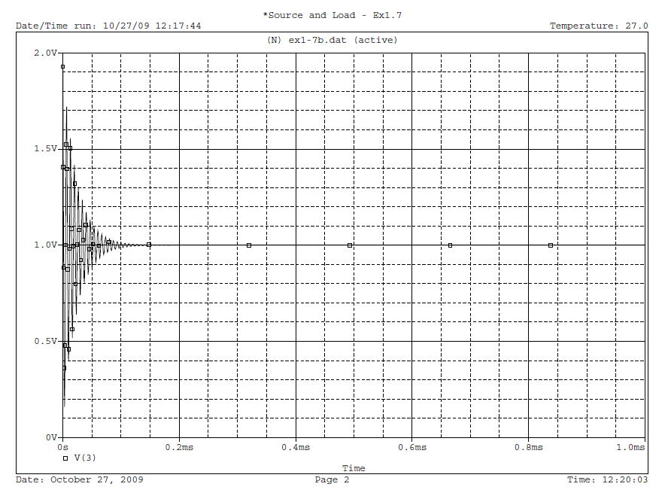

Figure 3 Transient Analysis for R1=10 kΩ

## Exercise 1.8

*Source and Load - Ex1.8

C2 1 0 200n

C1 0 2 200n IC=2V

L1 1 2 100m

Rf 3 4 9k

Rin 1 3 1k

Rout 4 2 100

Ri 0 3 1000000k

E 4 0 0 3 200000

.TRAN 1us 10ms UIC

.PROBE

.END

JOB CONCLUDED

TOTAL JOB TIME .06

In the following 3 figures:

Figure 1 has Rin = 1 kΩ and Rf = 9 kΩ yielding a gain of Rin/Rf = 1/9.

Figure 2 has Rin = 9 kΩ and Rf = 1 kΩ yielding a gain of 9.

Figure 3 shows a unit gain, meaning Rin = Rf.

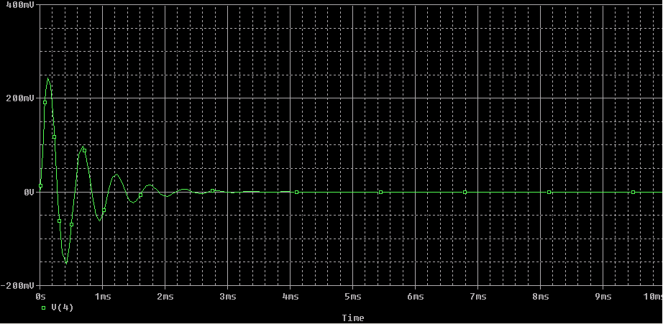

Figure 4 Screenshot of PSPICE Plot of 1.8 The Colpitts Oscillator Circuit Using Rin = 1kΩ and Rf = 9kΩ

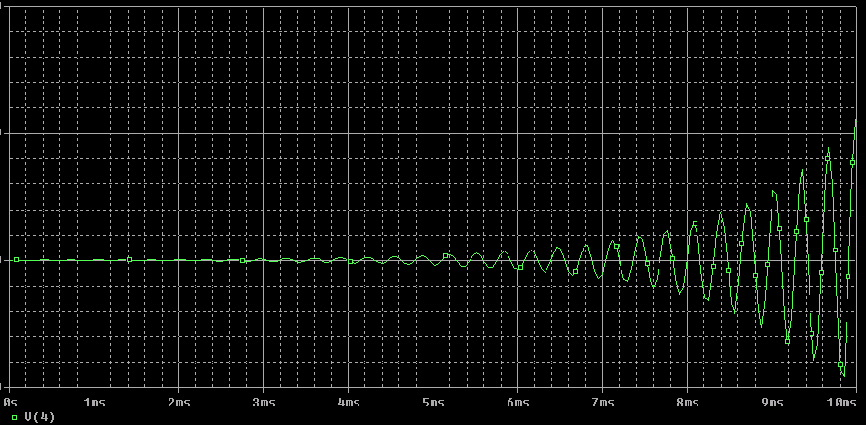

Figure 5 Screenshot of PSPICE Plot of 1.8 The Colpitts Oscillator Circuit Using Rin = 9kΩ and Rf = 1kΩ

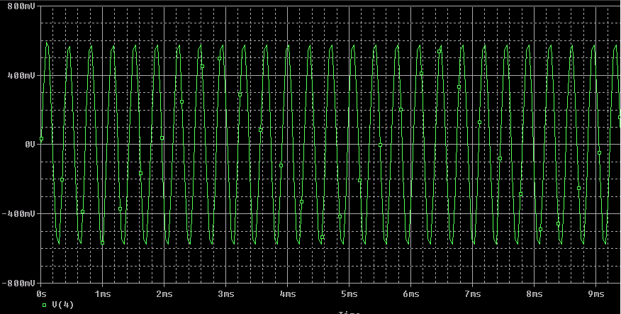

Figure 6 Screenshot of PSPICE Plot of 1.8 The Colpitts Oscillator Circuit With Gain of 1

## Exercise 1.9

*Source and Load - Ex1.9

C2 1 0 200n

C1 0 2 200n IC=2V

L1 1 2 100m

Rf 3 4 9k

Rin 1 3 1k

Rout 4 2 100

Ri 0 3 1000000k

D1 3 4 D1

D2 3 4 D1

.MODEL D1 D

E 4 0 0 3 200000

.TRAN 10us 10ms UIC

.PROBE

.END

**** 10/27/09 13:17:09 ************** PSpice Lite (Mar 2000) *****************

*Source and Load - Ex1.9

**** Diode MODEL PARAMETERS ***********************

D1

IS 10.000000E-15

JOB CONCLUDED

TOTAL JOB TIME .80



**Figure 7 Transient Analysis for Exercise 1.9**



**Figure 8 FFT Plot for Exercise 1.9**

## Exercise 1.10

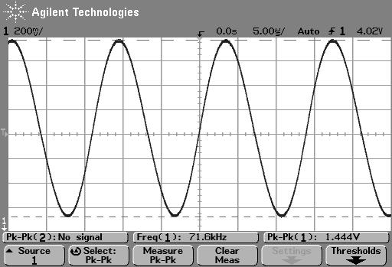

Figure 9: Screen Shot of Oscilloscope for the Transistor Colpitts Oscillator Circuit

# Appendix B

In the following figure, Figure 10, all three solvents are presented at once. The 3 observed frequency dips correspond to the 3 solvents studied: water, ethanol, and ethylene glycol. The temperatures of solutions were 23°C, 23.1°C, and 25.8°C respectively.

Figure 10: SRS QCM Frequency Readout For Different Solvents Over Time

The following table, , tabulates the average shift in frequency for the 3 solvents studied.

Table 3: Frequency Shift of Different Solvents from Air

|  |  |  |  |  |  |
| --- | --- | --- | --- | --- | --- |
|  | Dry Ambient QCM (Hz) | Shifted Frequency Value (Hz) | Actual Difference (Hz) | Calculated Difference (Hz) | Percentage Difference (%) |
| Water | 4989061.9 | 4988374.6 | -687 | -711.52 | 3.4% |
| Ethanol | 4989149.4 | 4988418.2 | -731 | -693.37 | 5.43% |
| Ethylene Glycol | 4989111.6 | 4986175.3 | -2936 | -3016.75 | 2.67% |

The procedure used to calculate the theoretical frequency shift given a solvent’s viscosity and density is outlined in Prelab 2. A sample calculation for water is shown below:



The percentage differences were calculated using the formula:



For water, for example, % diff = 

Table 4 Recorded Frequency Off the Frequency Counter at Different Temperatures

|  |  |  |
| --- | --- | --- |
| Temperature (°C) | Frequency (Hz) | Frequency Shift (Hz) |
| 10 | 4988324.1 | -783.53 |
| 13.6 | 4988339.2 | -768.43 |
| 16 | 4988347.8 | -759.83 |
| 19 | 4988364.7 | -742.93 |
| 22 | 4988386 | -721.63 |
| 25 | 4988394.2 | -713.43 |
| 28 | 4988404.3 | -703.33 |
| 31 | 4988411 | -696.63 |
| 34 | 4988432.7 | -674.93 |
| 37 | 4988435.7 | -671.93 |
| 40 | 4988432 | -675.63 |
| 43 | 4988463.6 | -644.03 |
| 46 | 4988448.9 | -658.73 |
| 49 | 4988480.8 | -626.83 |
| 52 | 4988461.3 | -646.33 |
| 55 | 4988468.6 | -639.03 |
| 58 | 4988482.8 | -624.83 |
| 61 | 4988484.2 | -623.43 |
| 64 | 4988490.1 | -617.53 |
| 67 | 4988511.6 | -596.03 |
| 69 | 4988512.9 | -594.73 |

Figure 11 Frequency Dependence of the QCM: Comparison between theoretical and experimental values

Figure 12 Frequency Readout for the Temperature Dependence Measurements

**Appendix C**

Figure 13 SRS QCM200 Readout for the Addition of Mercaptoundecanoic acid to the solution

Normalization on the data was performed to eliminate drift effects. This was done by using the slope of the line up until the QCM was immersed in the solution. This slope turned out to be 0.1368 which is then extrapolated for all 5 minutes since we assume a constant drift, and its value subtracted from all data points.

Table 5: Noise and Total Frequency Shift from the Addition of Mercaptoundecanoic Acid (MUA)

|  |  |  |  |  |  |  |
| --- | --- | --- | --- | --- | --- | --- |
| **Original Data** | Before MUA Addition (Hz) | After MUA Addition (Hz) |  | **Normalized Data** | Before MUA Addition | After MUA Addition (Hz) |
| Average | 4997820.24 | 4997817.23 |  | Average | 4997792.75 | 4997786.66 |
| Max | 4997821.00 | 4997819.20 |  | Max | 4997793.31 | 4997787.10 |
| Min | 4997819.30 | 4997815.80 |  | Min | 4997791.98 | 4997786.15 |
| Noise | 1.70 | 3.40 |  | Noise | 1.33 | 0.95 |
|  |  |  |  |  |  |  |
| Total Frequency Shift (Hz) | | -3.01 |  | Total Frequency Shift (Hz) | | -6.09 |

The averages values were calculated by taking the average of 5-6 values before and after the addition of mercaptoundecanoic acid (MUA). The total frequency shift was calculated by taking the difference between the average frequencies before and after the addition of

mercaptoundecanoic acid. For example, the total frequency shift for the original data is 4997820.24 - 4997817.23= -3.01

Noise levels are approximated by taking the difference between the maximum and minimum values of the 6 data points, once each for before and after the addition of MUA. For example, the noise for the original data before the addition of MUA is 4997821.00- 4997819.30= 1.70.

The following table, , summarizes the results of the analysis done on the data obtained in the lab. Sample calculations are shown below.

Table 6 Summary of Parameters from the Addition of Mercaptoundecanoic Acid

|  |  |  |  |
| --- | --- | --- | --- |
|  | **Original Data** | **Normalized Data** | **Units** |
| Δf | -3.01 | -6.09 | Hz |
| Cf | 5.8577E+07 | 5.8577E+07 | Hz cm2/g |
| Δm | 6.83E-08 | 1.38E-07 | g |
| MUA Acid MW | 218.36 | 218.36 | g/mol |
| Packing factor | 2.35227E-10 | 4.75874E-10 | mol/cm2 |
| Average Foot Print Area | 7.06E-15 | 3.49E-15 | cm2/molecule |
| Number of Gold Atoms | 5.65E+14 | 1.14E+15 | atoms |

**Sample Calculation for the Original Data to Obtain Parameter in :**

Here we recalculate Cf using an average frequency value for fo recorded *before* the

mercaptoundecanoic acid is added:



where *n*=1 and are the densities and shear modulus of quartz. The values for these constants were obtained from Prelab #2.

is be calculated using Equation 2 in the lab manual, namely 

We know that the molecular weight of mercaptoundecanoic acid is 218.36 g/mol.

Thus, packing factor =

The average footprint area can be calculated by:



Assuming 3 gold particles per thiol molecule, the number of gold particles is given by



The theoretical thickness of the SAM is obtained by assuming there are 11 carbon atoms with a bond length of 0.15 nm and a bond angle of 30°. This gives us a thickness of nm = 14.3 Å.

The first shift in the above figure corresponds to the ¼ dilution while the second shift corresponds with the full addition of the 50 mM lead acetate a few seconds later. All data has been normalized to remove the effects of drift.

Table 7: Total Frequency Shift and Noise of the 50 mM Lead Acetate Addition

|  |  |  |  |
| --- | --- | --- | --- |
|  | **Frequency Before Adding Lead Acetate (Hz)** | **Frequency After Adding Lead Acetate (Hz)** | **Difference (Before – After) (Hz)** |
| Stock 50 mM | 4998003.28 | 4997997.27 | 6.01 |
| ¼ Dilution | 4997956.08 | 4997954.55 | 1.53 |

Table 8 Summary of Parameters Obtained After Normalizing Data for Drift from the Addition of 50 mM Lead Acetate

|  |  |  |
| --- | --- | --- |
| Δf | -6.01 | Hz |
| Cf | 5.8581E+07 | Hz cm2/g |
| Δm | 1.36E-07 | G |
| Lead Ion MW | 207.2 | g/mol |
| Packing factor | 4.95009E-10 | mol/cm2 |
| Average Footprint Area | 3.35E-15 | cm2/molecule |

Table 9 Summary of Parameters Obtained After Normalizing Data for Drift from the Addition of 1/4th Dilution of 50 mM Lead Acetate

|  |  |  |
| --- | --- | --- |
| Δf | -1.53 | Hz |
| Cf | 5.8580E+07 | Hz cm2/g |
| Δm | 3.47E-08 | G |
| Lead Ion MW | 207.2 | g/mol |
| Packing factor | 1.25999E-10 | mol/cm2 |
| Average Footprint Area | 1.32E-14 | cm2/molecule |

We can calculate the percent difference between the packing factors obtained from the addition of mercaptoundecanoic acid and the addition of 50 mM lead acetate stock solution as follows:



# References

[1] L. Dubois, "Synthesis, Structure, and Properties of Model Organic Surfaces," Annu. Rev. Phys. Chem., vol. **43**, 1992, pp. 437-463.